Plot 2.

After analyzing 11.1M of Data related to HealthCare. I generated plot 2, which is the graph representation of breast cancer population based on their ethnics. I used “Data Platform” data set. See Figure 2. A java tool developed by me was used to facilitate the creation of the graph. Also the data extraction and analysis as done using Java. All the codes are public in the GitHub files.

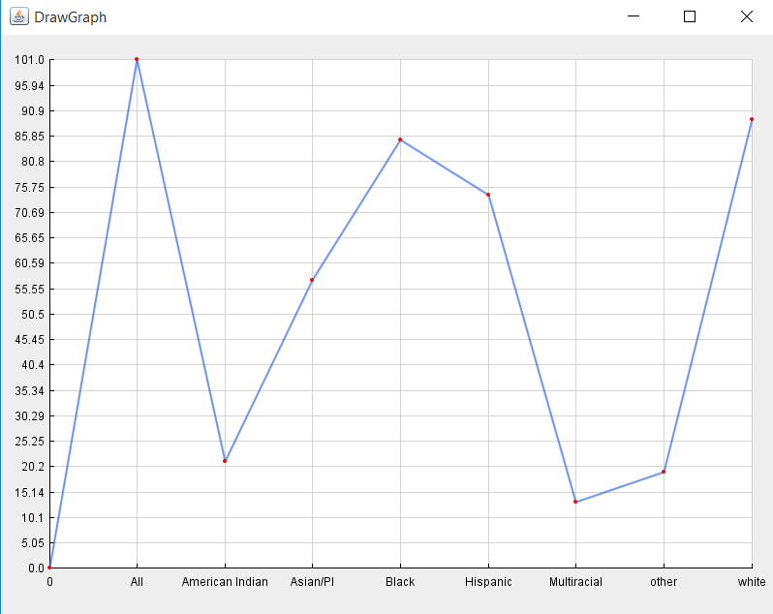

**Figure 2. Breast Cancer population based on Ethnics.**

**Figure 2 Data**

**Ethnic – Number of Cancer Breast Patients**

All --> 101

American Indian/Alaska Native --> 21

Asian/PI --> 57

Black --> 85

Hispanic --> 74

Multiracial --> 13

Other --> 19

White --> 8

Besides, I presented the population group by states into the US, see figure 3.

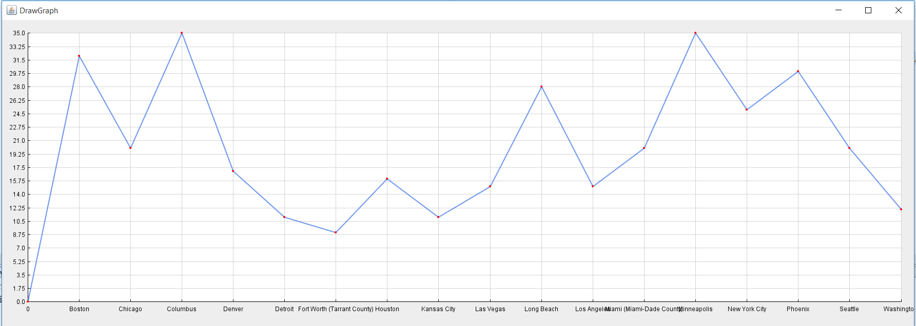

**Figure 3. Breast Cancer population based on States.**

**Figure 3 Data**

**City – Number Of Cancer Breast Patients**

Boston --> 32

Chicago --> 20

Columbus --> 35

Denver --> 17

Detroit --> 11

Fort Worth (Tarrant County) --> 9

Houston --> 16

Kansas City --> 11

Las Vegas (Clark County) --> 15

Long Beach --> 28

Los Angeles --> 15

Miami (Miami-Dade County) --> 20

Minneapolis --> 35

New York City --> 25

Seattle --> 20

Washington --> 12

**For more information check:** [**https://github.com/Danissa/DATAINCUBATOR/tree/master/DANISSA-DATA%20INCUBATOR**](https://github.com/Danissa/DATAINCUBATOR/tree/master/DANISSA-DATA%20INCUBATOR)